He changed my life in Guatemala.
Country Stats
- Team Leader: Brianna Kuck and Jonathan Ponce
- Team Size: 8
- Villages visited: 8
- Trip length: 11 days
- Spiritual ground conquered
- 700+ villagers heard the Gospel
- Video located at: https://vimeo.com/69838732
In this photo, Ezra Santiago is pictured leading the team and the village kids of Tiritibol in song. This day in Tiritibol was marked by supernatural team unity, anointed children’s ministry and an openness to the Gospel that this village had never experienced.
Photo Cred:
Jonathan Ponce

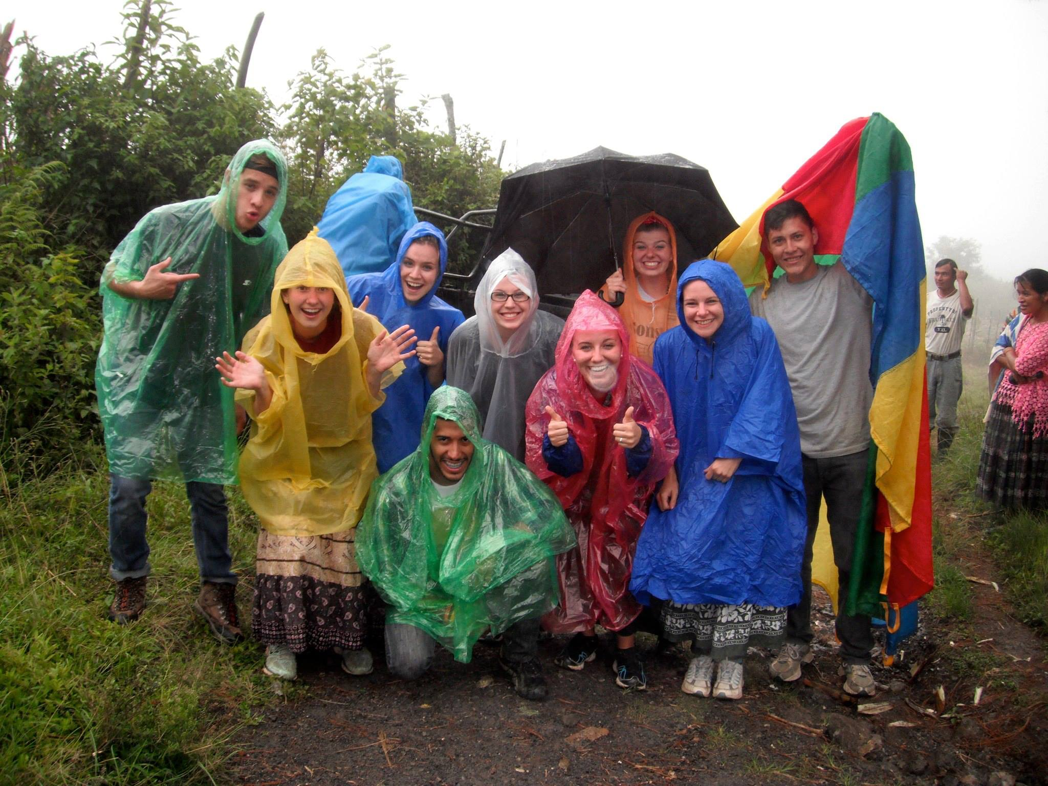

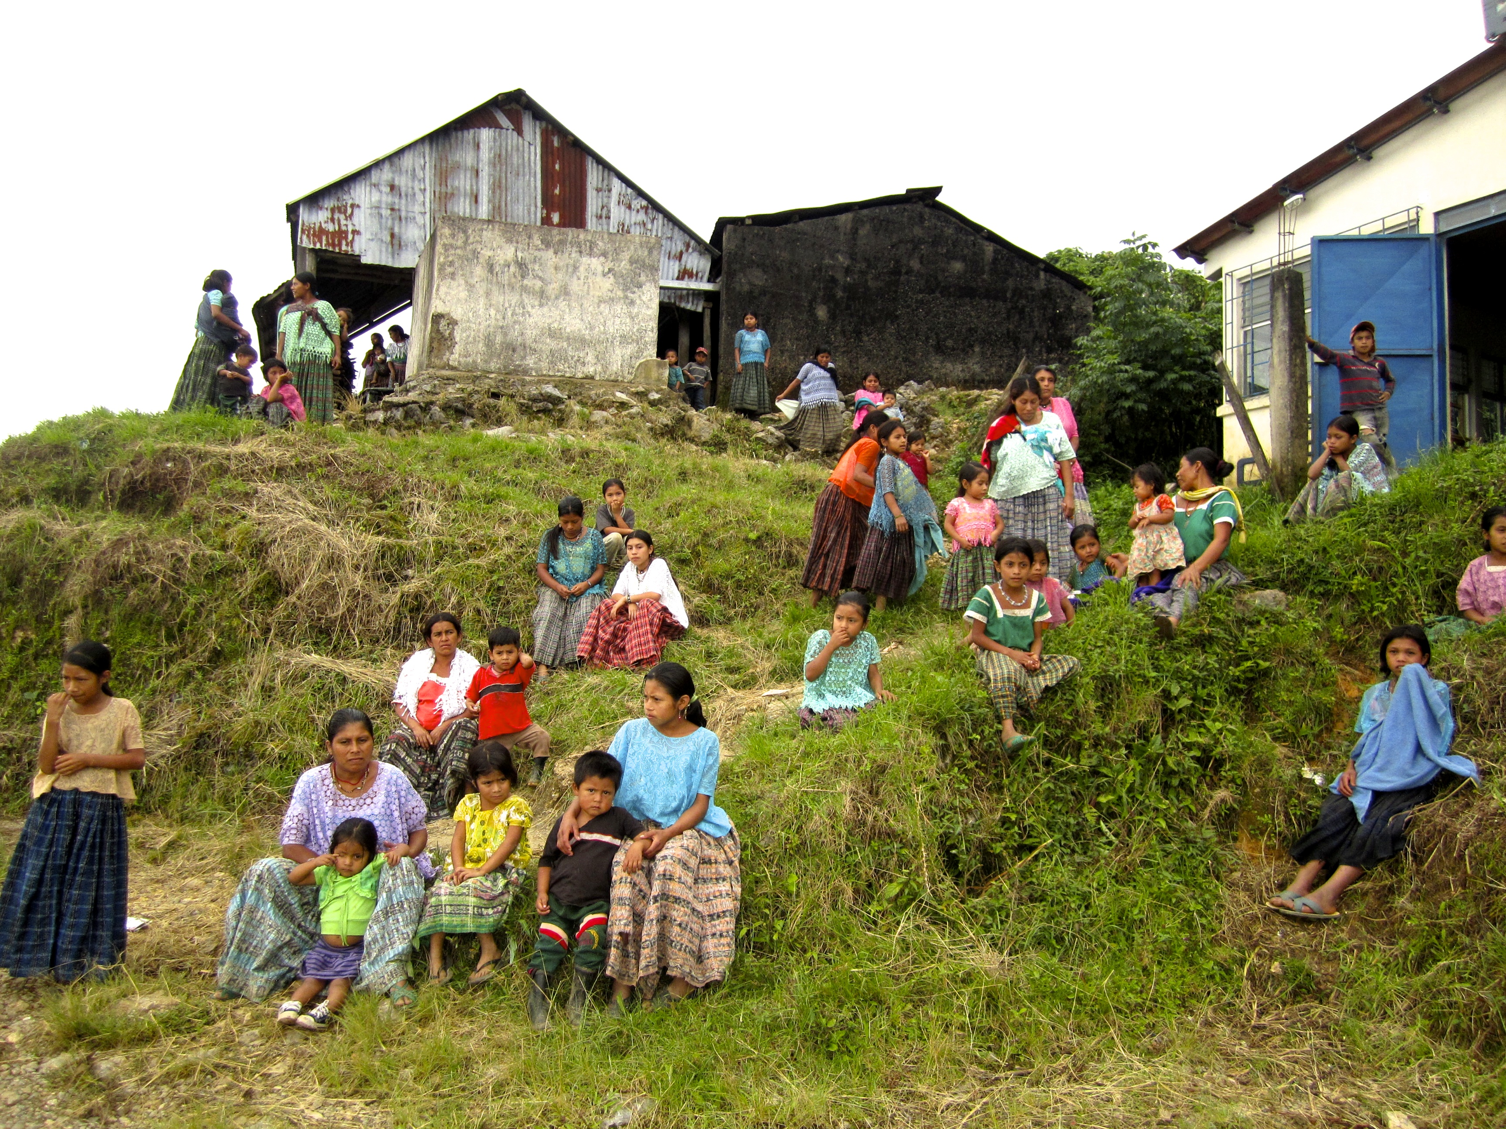
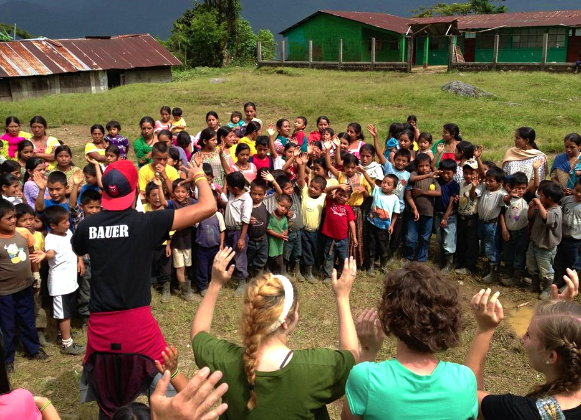

“It was a dark summer night, fire blazing. Yet unlike your typical American bonfire, this one was created to burn idols. We all crowded into the small church kitchen, mud walls and the idols only lit by the glow of the fire stove. The pastor had invited us to take part in this late night ceremony as we headed back from a long day of children’s ministry. The man that these idols belonged to had a son who had been experiencing seizures. They couldn’t seem to find the root of the issue. The pastor had asked him if they had idols of any kind in their house, but he denied being apart of the witchcraft. However, when he couldn’t take seeing his son suffer any longer, he brought the idols to the church pastor at 5 am so that the pastor could deal with them, and after that, his son was okay again!
This was not his first experience with this type of activity considering the heavy presence of witchcraft in the village of Beleju where he lives. The people spend their fortunes to line their houses with idols of every kind. At first sight, they looked so innocent with their smiling faces and their nativity-like appearance. However, as our missionary began to explain to us that the people actually worshipped these idols instead of God, and that behind each one of them was a demon being worshipped, I knew that it was time for them to go. We each got to take a hammer to them then tossed them in the fire. It was simply amazing to see this village family literally lay down their physical idols in order to follow Christ, and it was life-changing to see Jesus reign victorious in the village of Beleju.”
-Ashley Kuck
-

Summary

Eight team members, 8 hours from Guatemala City, 8 different villages. This Guatemala team worked with missionaries Bart and Pam Biddle, who have been evangelizing Quiche, Guatemala for over 15 years. Quiche is the poorest and most unreached department of Guatemala. The villages visited were: Beleju, El Soch, Tiritibol, Regadios, Chitas, Jumuc, San Marcos, and La Campana. They have no running water, no electricity and are filled with hearts that are plagued by the darkness of witchcraft. The purpose of this trip was to communicate the Gospel of Jesus Christ to the un-evangelized indigenous Mayan Indians living in this area through songs, dramas, children’s ministry, testimonies, Bible stories, and preaching. The dominion of darkness was shaken by the LIGHT and POWER of God flowing through the members of this team.

NOTHING could stop this team from bringing the Gospel.

A Student Story

The Power of a Polaroid.
Ashley Haag posing for a Polaroid with her new friends in San Marcos. The polaroid produced was the first photo these boys had ever held of themselves.

