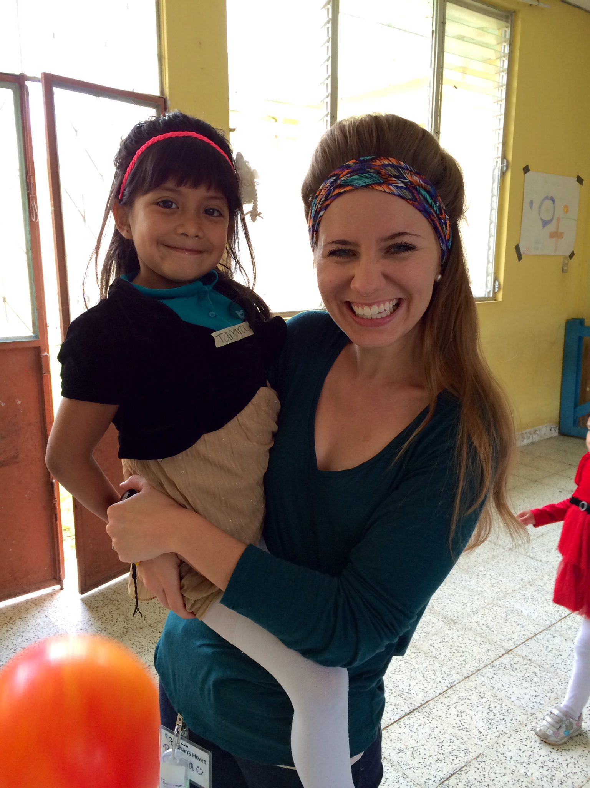=

I recently graduated with my Bachelor of Arts degree in Communication from Southeastern University. Following graduation, I had the privilege of living in Guatemala at a children’s malnutrition center in San Juan Sacatepaquez. The kids captured my heart like never before. I can say I left my heart in Guatemala!

I truly have a passion for Spanish and for Latin American countries, which perfectly fits my new role as Team Trip Coordinator at Teams Commissioned for Christ International. I also serve as an Event and Project Manager for Nathaniel’s Hope, a ministry for kids with special needs.

If you are going to make a financial contribution, please follow these easy steps:

1. Address checks to*Your Church Name* , and on the Memo line please write “**Guatemala –** *Your Name*”
2. Or you can give online at *Giving Website (i.e. church website or other fundraising website)*.

**Thank you so much for your support and contributions!**

**I will send you a wrap-up letter as soon as I return!**

I am blessed to be an extension of God’s hands and feet on a mission trip to Guatemala in June 2013 with my church, *Church Name Here*. I am SO excited to return to the culture and precious people that I have grown up serving. We will be working through the organization Teams Commissioned for Christ International with Bart and Pam Biddle, missionaries to Guatemala for over 15 years. Their ministry is based in the Department of Quiche, Guatemala, the most rural and poor part of the country (not to mention a very difficult area to travel to). Currently there are three areas that still have to be evangelized. Our mission is to share the gospel with these villages so that Evangelical churches can be planted.

We will be doing children’s ministry, dramas, construction, house-to-house ministry, church services, and more.

## What the Trip is About!

## How you can help.

There are two ways that I am asking for support. **The first is through your prayers.** Prayer is the most powerful tool we as Christians have and through your prayers we will make change happen and it will prepare the peoples’ hearts and minds before we even go. Please keep our team and myself in prayer as we go on this journey.

**The second way is through financial support.** **The trip will be costing $1100** for 11 days including travel expenses, housing, transportation and food. Whatever amount you feel led to give will help take us one step closer to going on this trip. Your contribution is greatly appreciated.

Each avenue you choose will make you a partner in this mission trip and you can have the assurance that people’s lives will be touched and some even changed for eternity.

3

## Final Steps of Support.

1

2

## Personal Update

June 20 – June 30, 2013

Destination: Guatemala